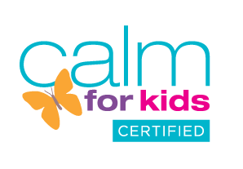



Yoga Nuts – Summer 2026
We will be running our club again on Tuesday lunchtimes. We use a mixture of games and stories to make yoga fun. We focus on feeling good and learn techniques to deal with anxieties and worries.
Time: 12.00-12.30.
Club dates: 21st April to 7th July. £55.00 for the 11 week course. 10% Sibling discount available.
What does my child need? Children take part in uniform, those wearing dresses or skirts may want to put shorts on underneath.
How to book: Please complete and email this form to me along with your payment. Payment is by PayPal to boxmooryoga@yahoo.co.uk or bank transfer to M Oliver, 308049, 32206968.
Child’s name:

Year:

Health issues:

Parent/carer email

I consent to Boxmoor Yoga emailing me about classes
Emergency contact telephone:

I look forward to welcoming your child to our club!
Maria Oliver BWY Dip
www.boxmooryoga.co.uk
boxmooryoga@yahoo.co.uk

